**Lab 6: Hosting wordpress site using ec2 and RDS**

Task1: create your ec2 and ssh login

Task2:Install LAMP(linux, apache, mariadb, php)

Task3:Setup RDS Mariadb Database

Task4:Edit security group of RDS

Task5:Connect to RDS Mariadb from EC2

Task6:Complete WordPress Installation

**Theory:**

### **Amazon EC2** (Elastic Compute Cloud):Amazon EC2 is an online computer you can use to run apps or websites. You can choose how powerful the computer should be and change it anytime.

### **LAMP Stack:** The LAMP stack is a collection of software used to host web applications, consisting of Linux as the operating system, Apache as the web server software that serves website content, MariaDB as the database management system (DBMS) to store website data, and PHP as the server-side scripting language that creates dynamic content on the website. This stack provides a powerful platform for deploying and managing websites, including applications like WordPress.

### **RDS (Relational Database Service):** A managed service by AWS that allows you to set up, operate, and scale relational databases in the cloud.

### **Security Group:** A **Security Group** is a virtual firewall used in cloud environments (like AWS) to control inbound and outbound traffic to and from resources such as EC2 instances. It defines rules that specify allowed or denied traffic based on factors like IP addresses, ports, and protocols. Security groups are stateful, meaning if you allow incoming traffic, the response is automatically allowed regardless of the outbound rules.

### **WordPress:** **WordPress** is an open-source content management system (CMS) used to create and manage websites. It is written in PHP and uses MySQL or MariaDB for database management. WordPress provides a user-friendly interface for creating websites, blogs, and online stores, and it offers a wide range of plugins and themes for customization, making it a popular choice for building dynamic websites.

### 

### 

**STEPS:**

Step 1: Launch EC2 Instance and ssh login

## First, I created an EC2 instance using the AWS Management Console by selecting the desired instance type and configuration. After the instance was up and running, I downloaded the key pair (PEM file) and used it to SSH into the EC2 instance from my terminal, allowing me to access and manage the instance securely.

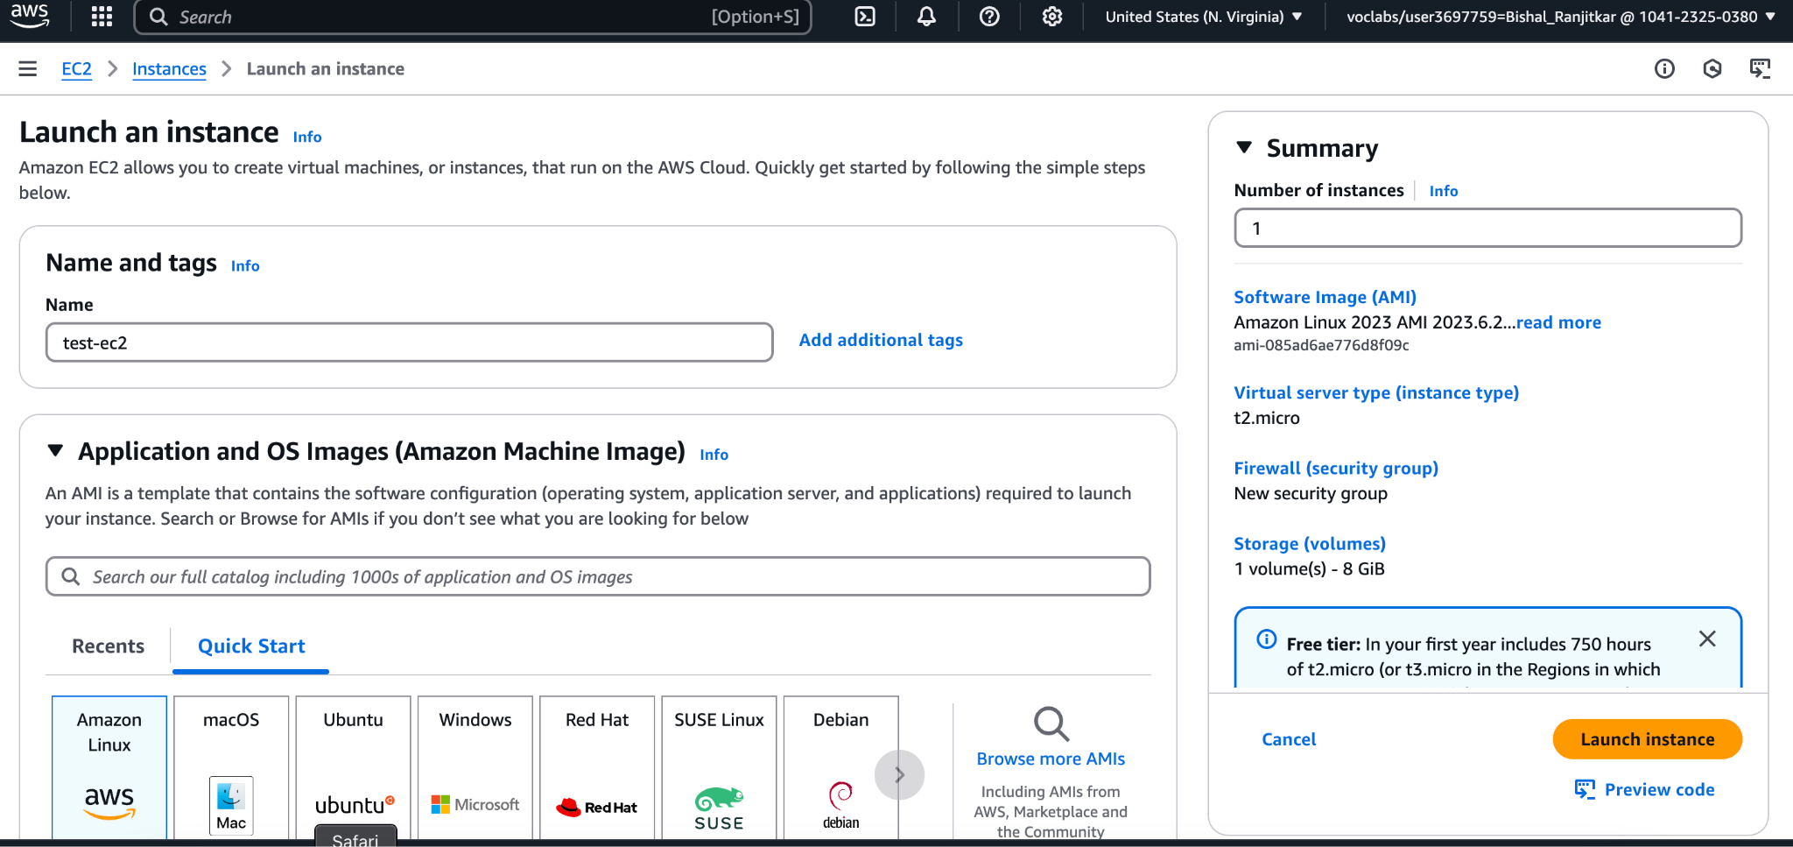

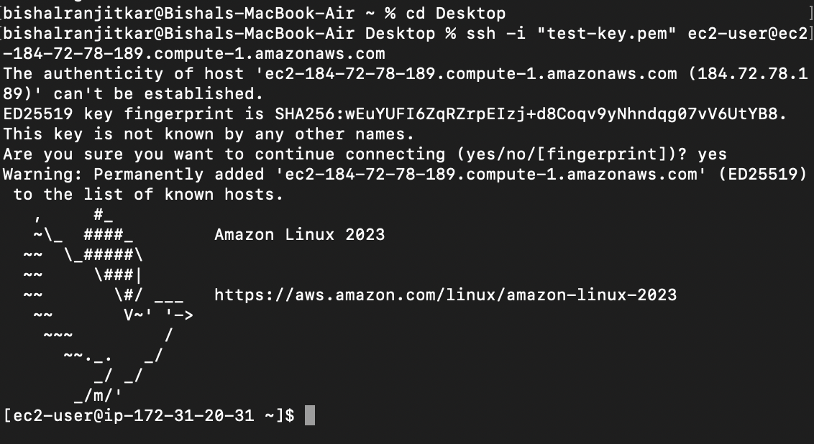

Task2:Install LAMP(linux, apache, mariadb, php)

After logging into the EC2 instance, I installed the LAMP stack. I updated the package manager and then installed Apache, MariaDB, and PHP . I made sure to start the Apache and MariaDB services and configured PHP to work with Apache, setting up the environment for hosting the WordPress site.

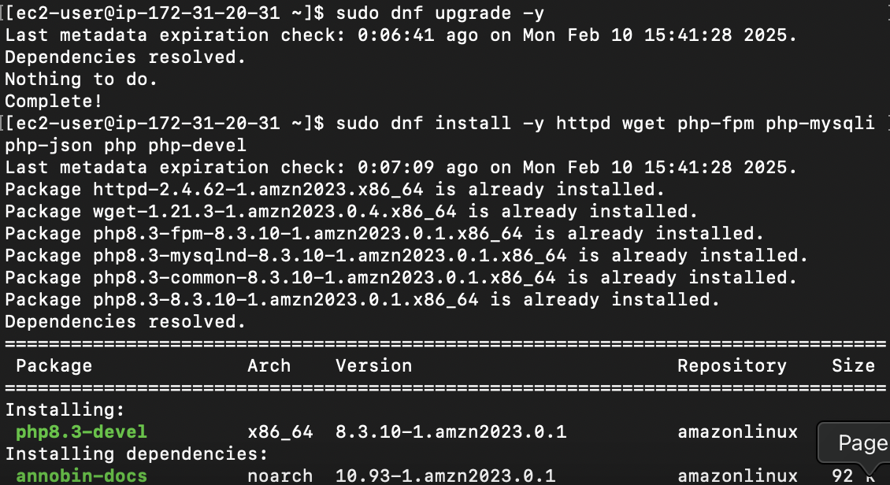

Task3:Set Up RDS Mariadb Database

In the AWS Management Console, I created an RDS instance with MariaDB as the database engine. I configured the instance size, storage, and security settings. Once the RDS instance was created, I saved the database endpoint and credentials, which I would use to connect to the database from my EC2 instance.

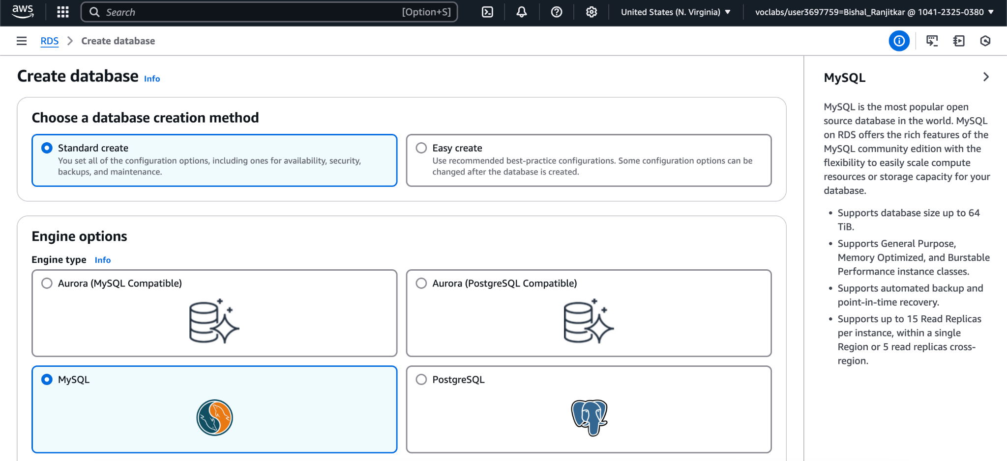

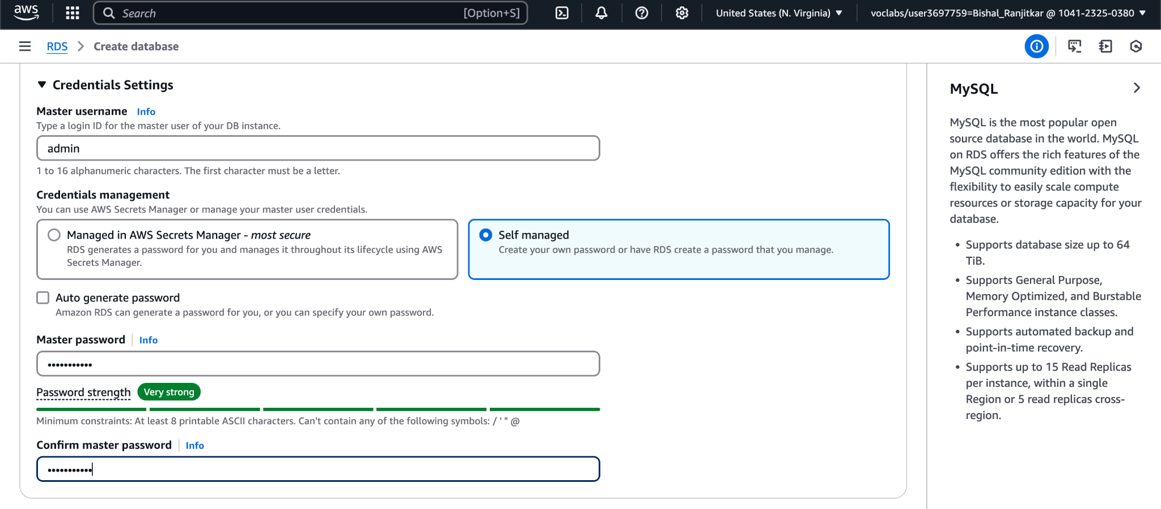

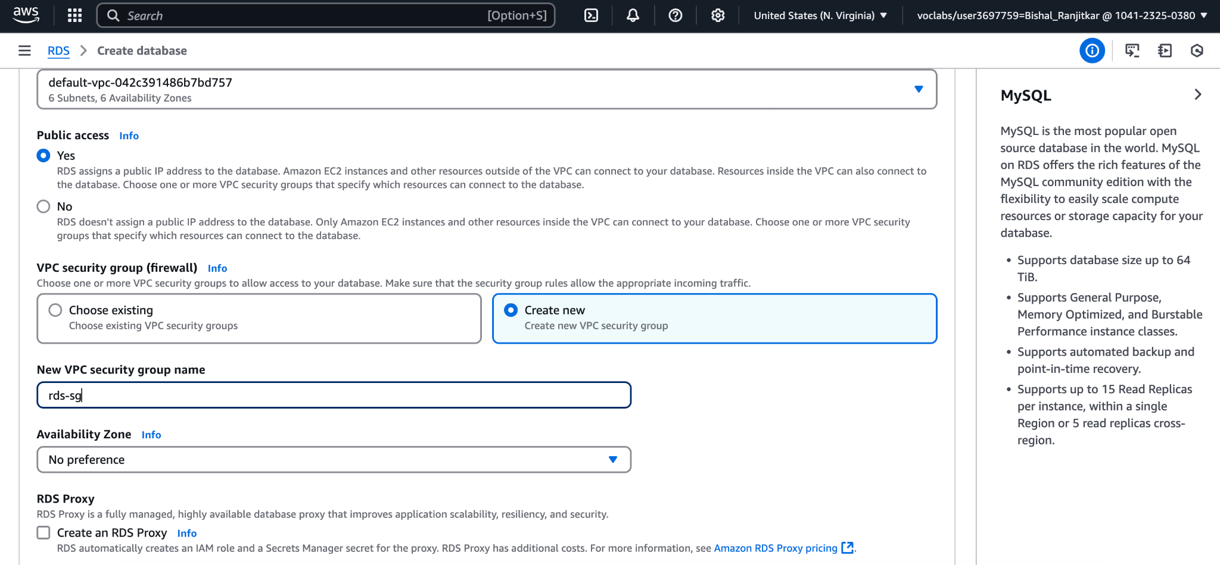

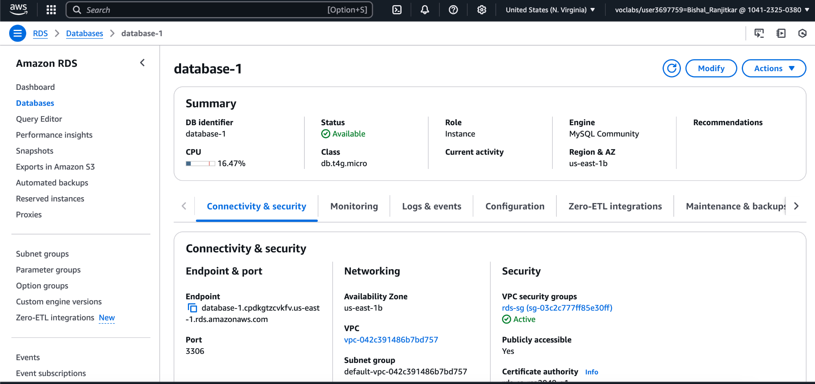

Task4:Edit security group of RDS

To allow communication between my EC2 instance and the RDS database, I edited the security group settings of the RDS instance. I added an inbound rule to permit traffic on the MySQL port (3306) from my EC2 instance's security group, ensuring both instances could securely interact.

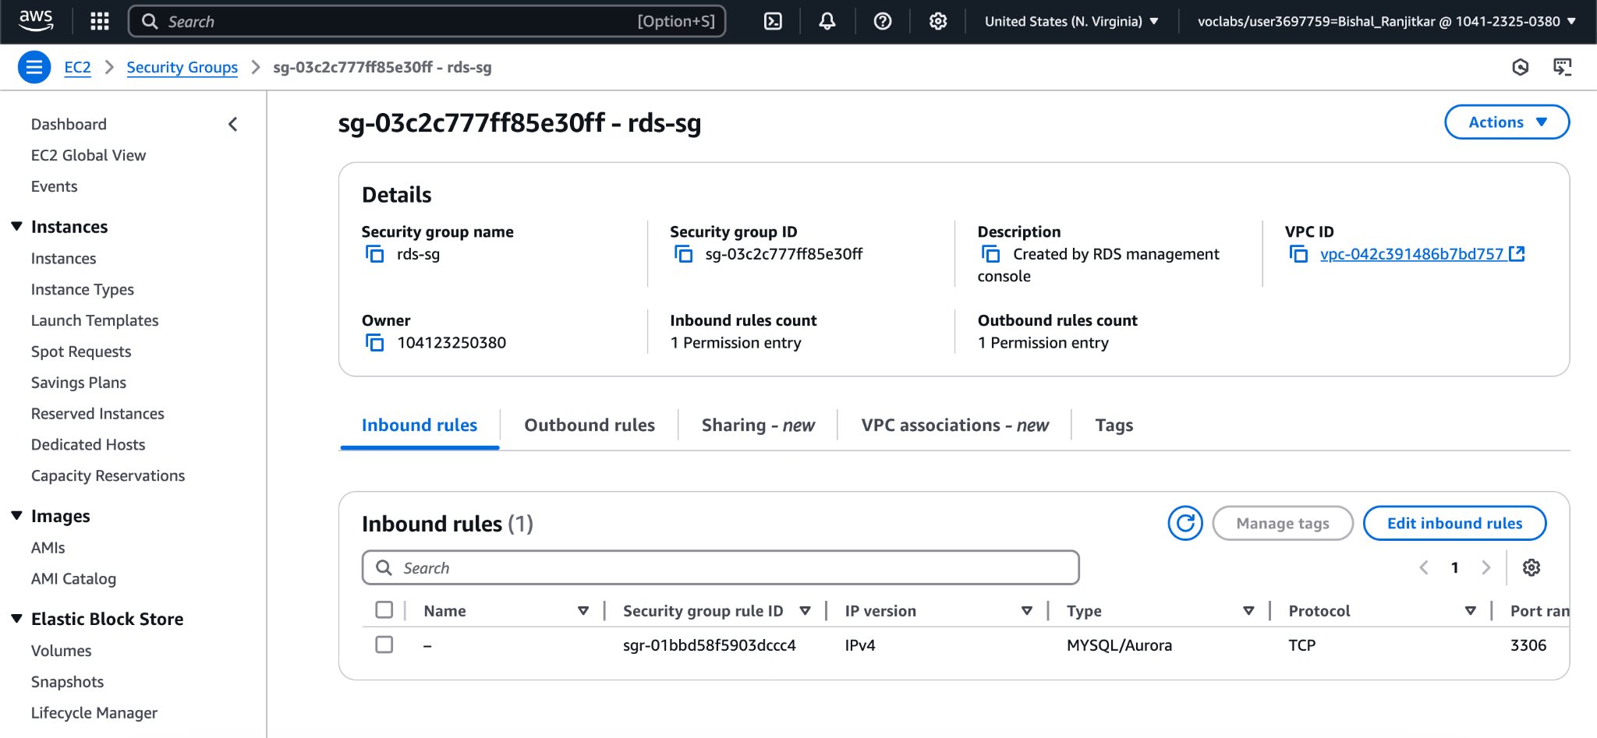

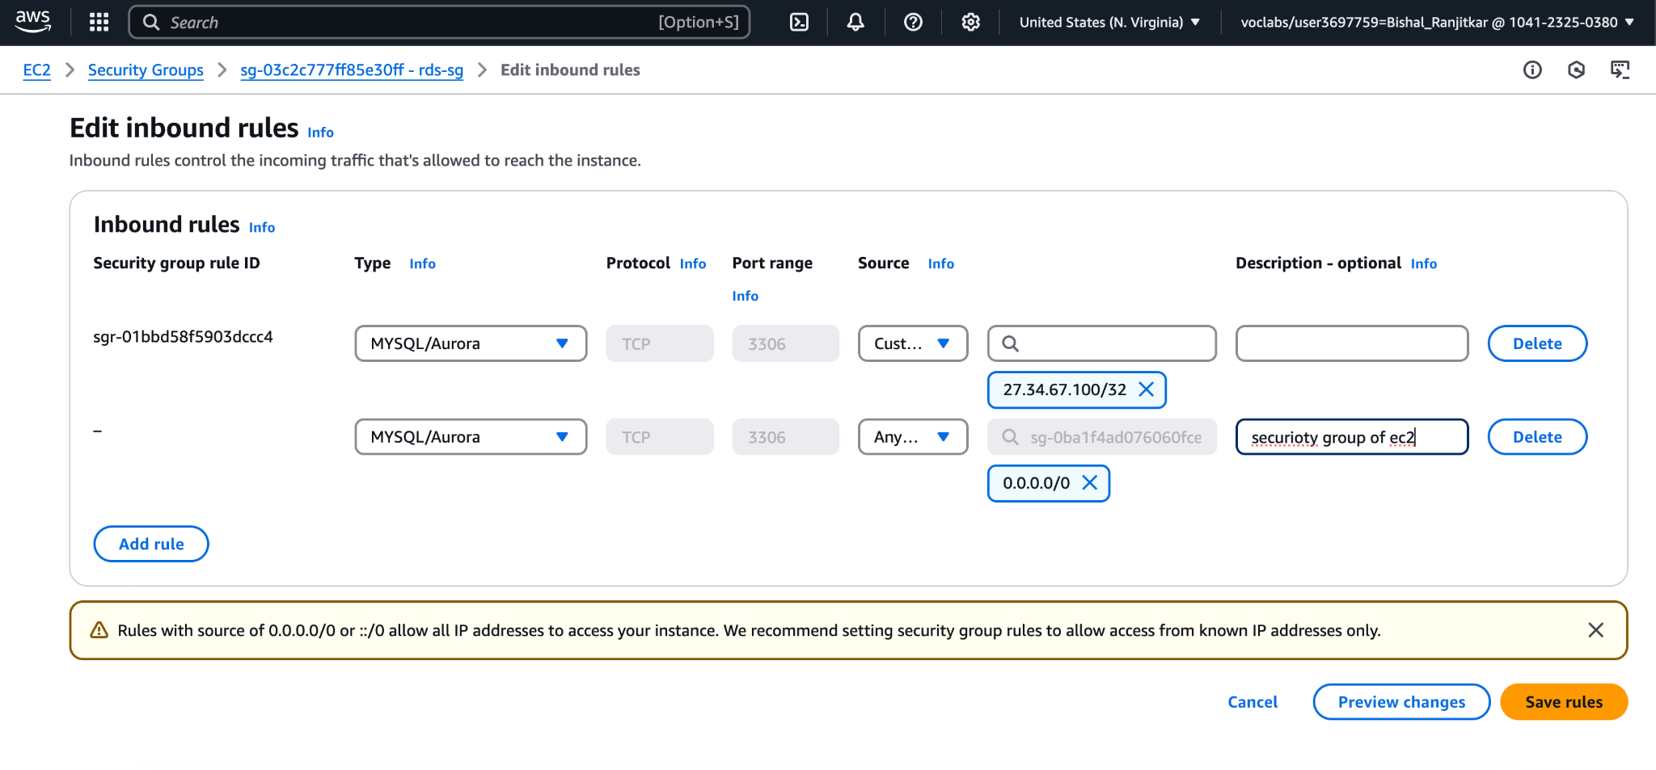

Task5:Connect to RDS MariaDB databasefrom EC2

With the security groups configured, I updated the WordPress configuration file (wp-config.php) on my EC2 instance. I entered the RDS database endpoint, database name, and credentials to enable my WordPress site to connect to and interact with the MariaDB database running on RDS.

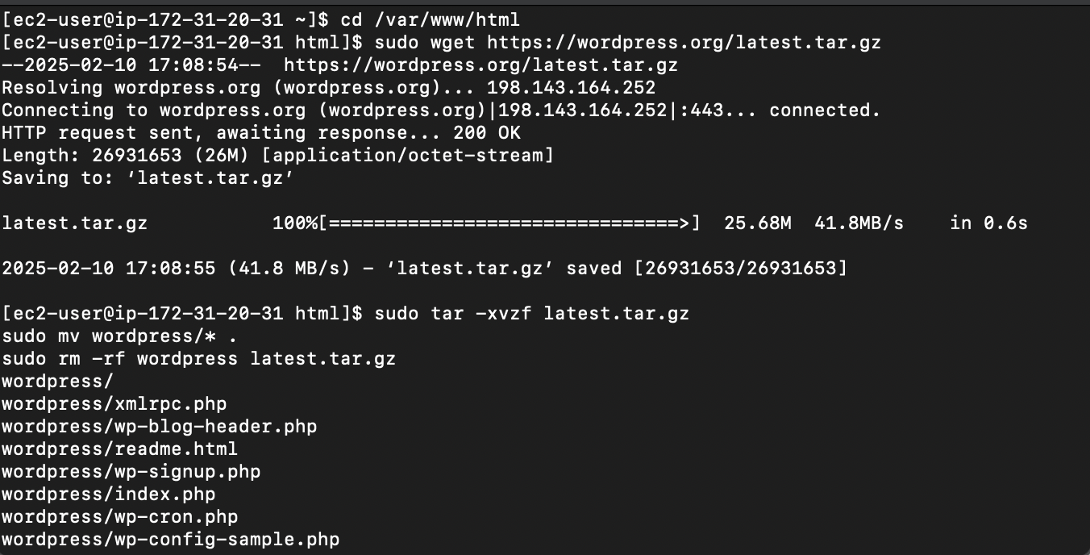

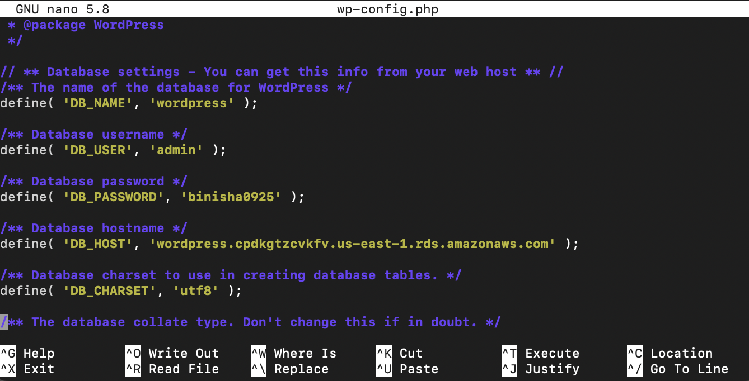

Task6:Complete WordPress Installation

Finally, I completed the WordPress installation by navigating to the public IP address of my EC2 instance in a web browser. I followed the on-screen prompts to configure my site, entering the database details (from the RDS instance) and finishing the setup process to have a fully functional WordPress site running.

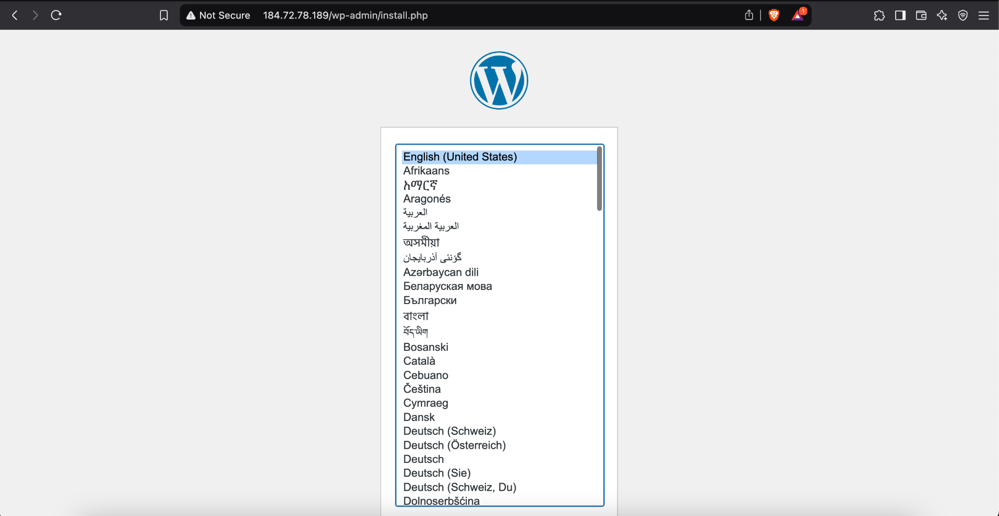

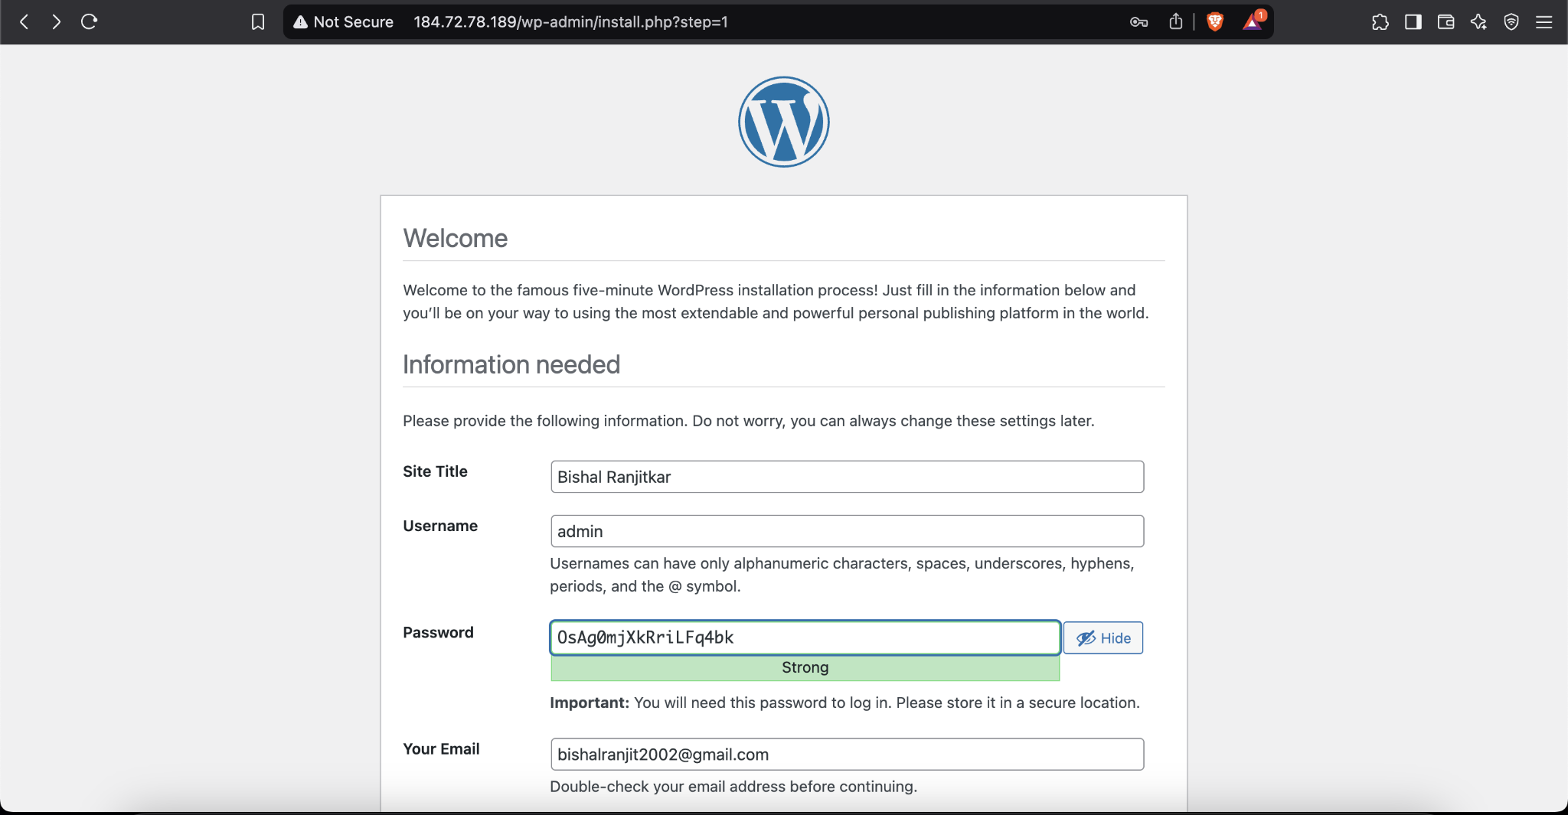

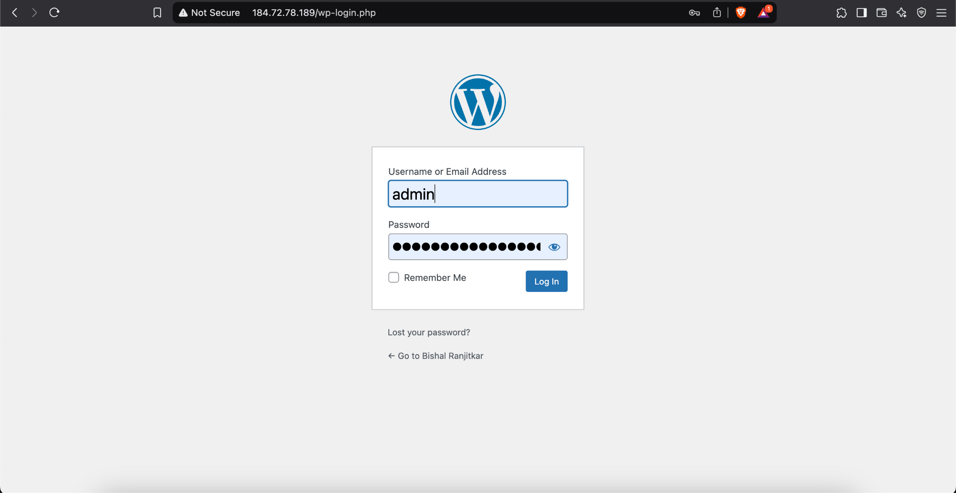

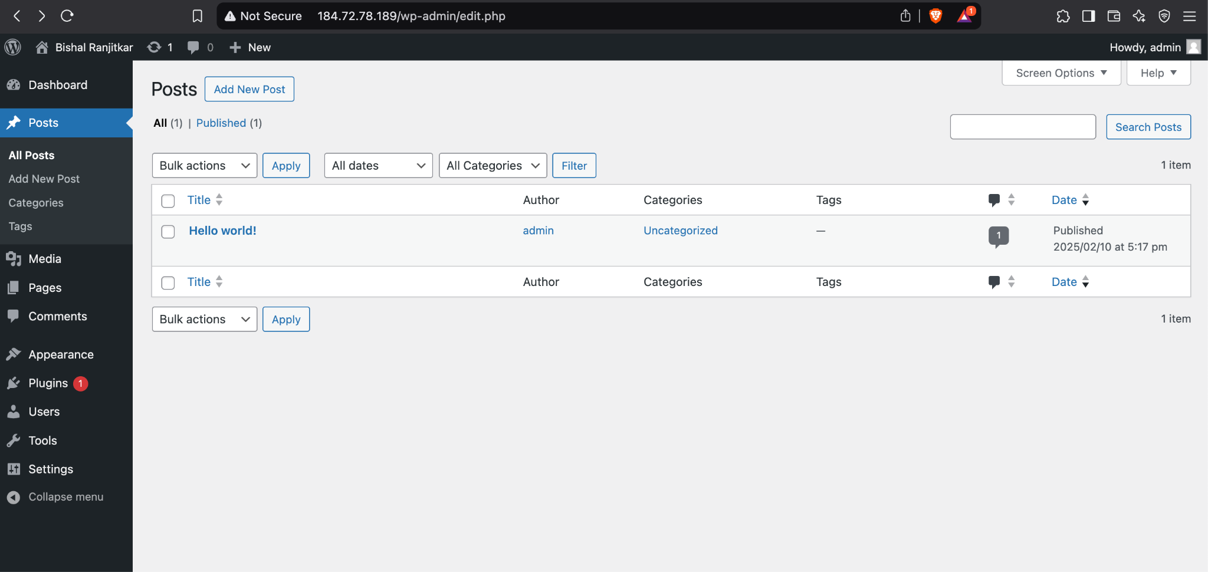

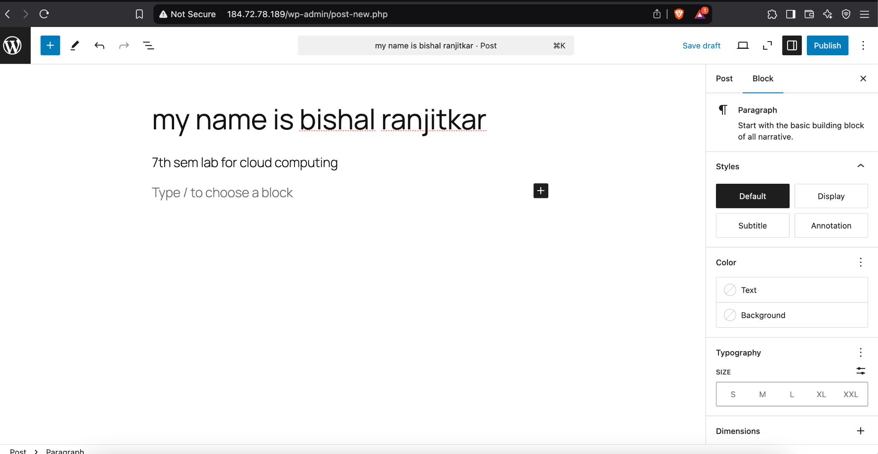

**Conclusion:**

In this lab, I learned how to set up and configure a WordPress site on AWS using EC2 and RDS. I gained hands-on experience with launching an EC2 instance, installing the LAMP stack, setting up a MariaDB database on RDS, and configuring security groups to enable communication between EC2 and RDS. I also learned how to connect my EC2 instance to the RDS database and complete the WordPress installation, giving me a deeper understanding of cloud-based hosting and database management.